BRAZILIAN E-COMMERCE MARKETPLACE SALES ANALYSIS
1. Project Overview and Objective
This project involves cleaning, transforming, and analysing the Olist Brazilian E-Commerce Marketplace dataset using Excel and creating an interactive Power BI dashboard to derive meaningful business insights into sales, customer behaviour, and delivery performance.
The main objective is to demonstrate data pre-processing techniques using Excel and an interactive Power BI dashboard to visualize Brazilian e-commerce sales data and derive meaningful business insights.

2. Data Sources
- Source Description and Timeline: Olist Brazilian E-Commerce Marketplace Dataset (Kaggle), covering orders placed between 2016 and 2018.
- Domain: E-Commerce/ Retail/ Sales Analytics.

3. Problem Statement
- To analyse e-commerce sales performance across product categories, months, payment types, and geographical locations.
- To identify sales trends and understand the performance of different product categories and regions.
- To analyse customer orders, payment preferences, and average order value for better business decision-making.
- To understand delivery-related factors such as delivery time, shipping cost, and product load for improved e-commerce analysis.

4. Attribute (Column /Features) Details:
Attribute Name | Data Type | Description
Order_ID | String (Text) | Unique identifier for each order
Customer_ID | String (Text) | Unique identifier for each customer
Product_ID | String (Text) | Unique identifier for each product
Seller_ID | String (Text) | Unique identifier for each seller
Order_Status | Categorical | Status of the order (e.g. delivered, shipped, canceled)
Order_Purchase_  Timestamp | Date/Time | Date and time when the order was placed
Price | Numeric (Decimal) | Price of the product
Freight_Value | Numeric (Decimal) | Shipping cost of the product
Payment_Type | Categorical | Payment method used for the order
Product_Category_  Name | Categorical | Category of the product
Customer_Zip_Code | Numeric | ZIP code prefix of the customer location
Sales_City | Categorical | City where the customer is located
Sales_State | Categorical | State where the customer is located
Product_Weight_G | Numeric (Integer) | Weight of the product in grams
Product_Load | Categorical (calculated) | Load category based on product weight
Final_Price | Numeric (Decimal) (calculated) | Product price including shipping cost
Time_Delivery | Numeric (Integer) (calculated) | Time taken to deliver the order

5. Tools & Technologies
- Excel: Data cleaning, transformation, VLOOKUP, calculated fields, Pivot Tables, and Pivot Charts.
- Power BI: Data modelling, DAX calculations, data visualization, and interactive dashboard creation.

6. Data Pre-Processing (Excel / Power Query)
Tasks Performed:
- Data Cleaning & Transformation: Removed duplicate records, handled missing and inconsistent values, standardized data formats, removed irrelevant columns, and created calculated fields such as Final Price, Delivery Time, Product Weight, and Product Load.
- Data Integration: Used VLOOKUP to combine information from different datasets, including customer, product, payment, location, and order details.
- Filtering & Sorting: Sorted and filtered the data based on relevant fields such as Product Load and Shipping Limit Date for analysis.
- Pivot Tables: Created Pivot Tables and Pivot Charts to summarise sales by product category, state, payment method, delivery charges, and product load.
- Fact and Dimension Tables: Prepared separate analytical tables such as Sales Details, Products Details, Customers Location, Sellers Location, Orders Delivery, Order Payments, Order Reviews, and Geography for Power BI data modelling.

7. Data Modelling and DAX (Power BI)
- Data Model: Imported the cleaned Excel dataset into Power BI and established one-to-many relationships between Customers_Location and Sales_Details, Sellers_Location and Sales_Details, Products_Details and Sales_Details, Orders_Delivery and Order_Payments, Orders_Delivery and Order_Reviews, and Customers_Location and Orders_Delivery, along with a many-to-many relationship between Geography and Sales_Details using Zip_Code.
SCREENSHOT OF DATA MODELLING
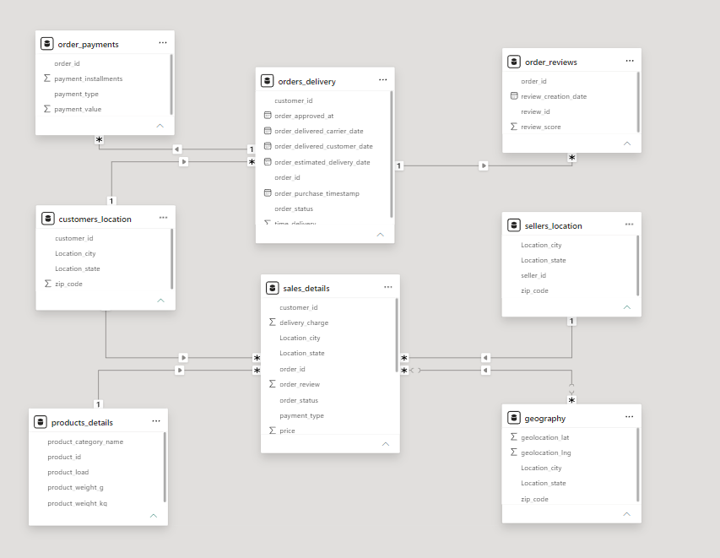
- Calculated Columns & DAX Measures: Implemented DAX measures for Total Sales, Total Orders, Total Customers, and Average Order Value.

8. Analysis and Visualizations (Power BI)
Dashboard Features:
- Multiple Visualizations based on problem statement: Created different visualizations to analyse and communicate e-commerce sales insights, including:
  - Bar Chart – Sales by Product Category
  - Bar Chart – Sales by Month
  - Column Chart – Yearly Sales Trend
  - Donut Chart – Sales by Payment Type
  - Bar Chart – Sales by Payment Type
  - Map – Sales by Geographical Location
  - Cards – Total Sales, Total Orders, Total Customers and Average Order Value
- Interactive Layout: Used filters, slicers and drill-down features to allow users to explore the report and analyse the data from different perspectives.
- Bookmarks: Used bookmarks to provide an interactive and user-friendly navigation experience between report views.
- Clear Titles and Labels: Added appropriate titles, data labels, legends, and headings to make each visualization easy to understand.
- Consolidated Report / Dashboard: Combined KPI cards, charts, and geographical visualizations into a single interactive Brazilian E-Commerce Marketplace Sales Analysis report.
SCREENSHOT OF DASHBOARD /REPORT
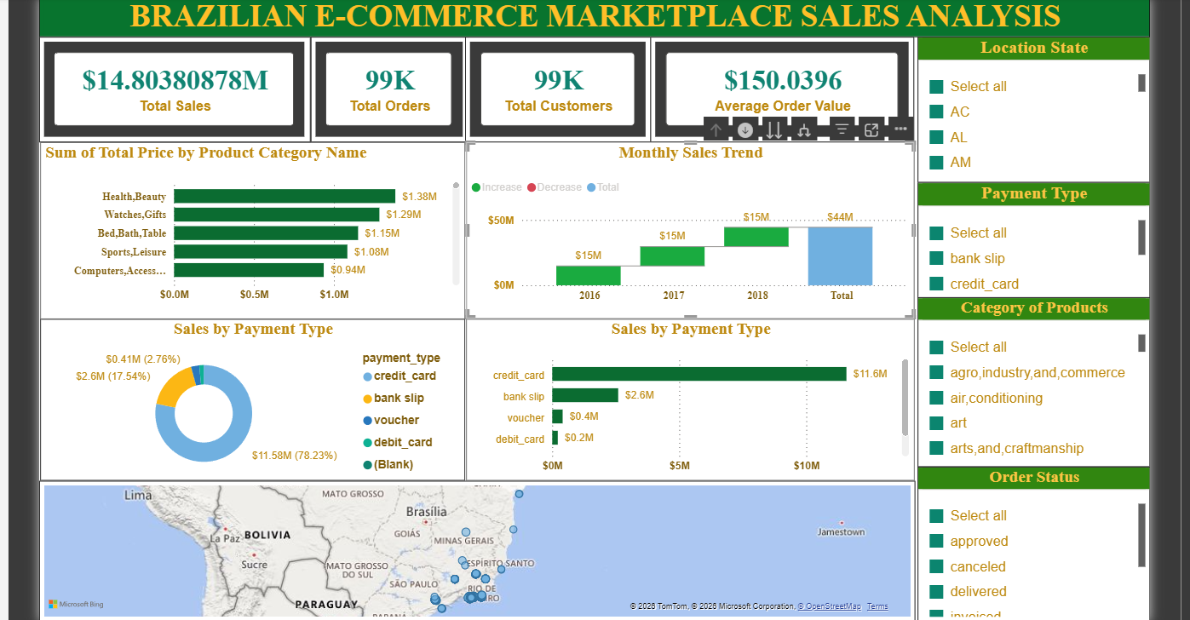

9. Insights & Conclusions
- Key Findings: Certain product categories and states generate disproportionately higher revenue, credit card is the dominant payment method, and delivery time varies notably by product load category and state.
- Provide the analysis insights:
    - Descriptive: Analysed sales by product category, payment type, month, year, and location, and summarised total sales, orders, customers, and average order value.
    - Diagnosis: Compared sales performance across product categories and geographical locations, and examined payment preferences and sales trends to understand performance differences.
    - Predictive: No predictive model or forecasting technique was implemented; the dashboard is mainly used for descriptive and diagnostic analysis.
    - Prescriptive: The analysis can support decisions related to product performance, payment preferences, geographical sales focus, and delivery/logistics improvements.
10. Conclusions
The integration of Excel and Power BI proved effective for end-to-end analysis of the Brazilian E-Commerce Marketplace dataset, from data cleaning and transformation to data modelling and interactive visual reporting. The project helped identify sales patterns across products, payment types, time periods, and geographical locations, supporting better business decision-making.

